Data Dictionary Scrum Groep 13

Tabellen

|  |  |  |  |  |  |  |  |  |  |  |
| --- | --- | --- | --- | --- | --- | --- | --- | --- | --- | --- |
| **Naam** | | ***dbo.Lijst*** | | | | | | | | |
| **Definitie** | |  | | | | | | | | |
|  | ***Column_name*** | ***Type*** | ***Computed*** | ***Length*** | ***Prec*** | ***Scale*** | ***Nullable*** | ***TrimTrailingBlanks*** | ***FixedLenNullInSource*** | ***Collation*** |
| **1** | songid | int | no | 4 | 10 | 0 | no | (n/a) | (n/a) | NULL |
| **2** | top2000jaar | int | no | 4 | 10 | 0 | no | (n/a) | (n/a) | NULL |
| **3** | positie | int | no | 4 | 10 | 0 | no | (n/a) | (n/a) | NULL |

|  |  |  |  |  |  |  |  |  |  |  |
| --- | --- | --- | --- | --- | --- | --- | --- | --- | --- | --- |
| **Naam** | | ***dbo.Song*** | | | | | | | | |
| **Definitie** | |  | | | | | | | | |
|  | ***Column_name*** | ***Type*** | ***Computed*** | ***Length*** | ***Prec*** | ***Scale*** | ***Nullable*** | ***TrimTrailingBlanks*** | ***FixedLenNullInSource*** | ***Collation*** |
| **1** | songid | int | no | 4 | 10 | 0 | no | (n/a) | (n/a) | NULL |
| **2** | artiestid | int | no | 4 | 10 | 0 | no | (n/a) | (n/a) | NULL |
| **3** | titel | nvarchar | no | 200 |  |  | no | (n/a) | (n/a) | SQL_Latin1_General_CP1_CI_AS |
| **4** | jaar | int | no | 4 | 10 | 0 | yes | (n/a) | (n/a) | NULL |

|  |  |  |  |  |  |  |  |  |  |  |
| --- | --- | --- | --- | --- | --- | --- | --- | --- | --- | --- |
| **Naam** | | ***dbo.Artiest*** | | | | | | | | |
| **Definitie** | |  | | | | | | | | |
|  | ***Column_name*** | ***Type*** | ***Computed*** | ***Length*** | ***Prec*** | ***Scale*** | ***Nullable*** | ***TrimTrailingBlanks*** | ***FixedLenNullInSource*** | ***Collation*** |
| **1** | Artiestid | int | no | 4 | 10 | 0 | no | (n/a) | (n/a) | NULL |
| **2** | naam | nvarchar | no | 200 |  |  | no | (n/a) | (n/a) | SQL_Latin1_General_CP1_CI_AS |

|  |  |  |  |  |  |  |  |  |  |  |
| --- | --- | --- | --- | --- | --- | --- | --- | --- | --- | --- |
| **Naam** | | ***dbo.Top2000Jaar*** | | | | | | | | |
| **Definitie** | |  | | | | | | | | |
|  | ***Column_name*** | ***Type*** | ***Computed*** | ***Length*** | ***Prec*** | ***Scale*** | ***Nullable*** | ***TrimTrailingBlanks*** | ***FixedLenNullInSource*** | ***Collation*** |
| **1** | Jaar | int | no | 4 | 10 | 0 | no | (n/a) | (n/a) | NULL |
| **2** | Titel | varchar | yes | 21 |  |  | yes | no | yes | SQL_Latin1_General_CP1_CI_AS |

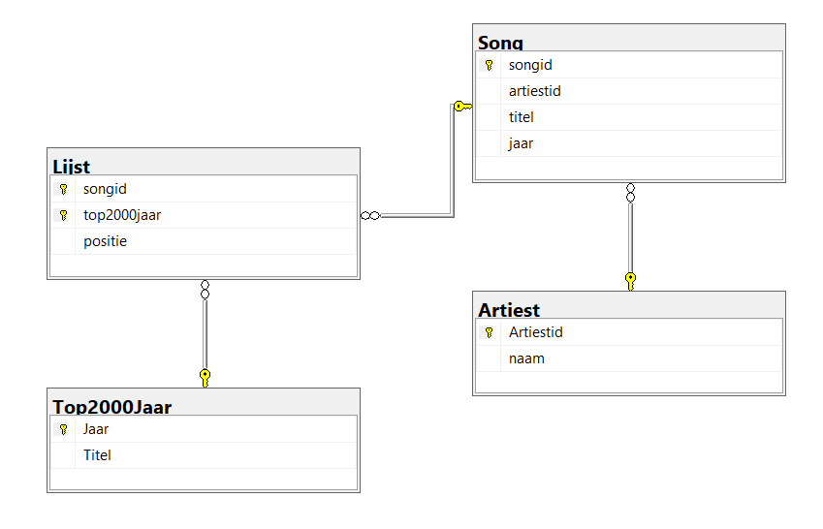ERD

Bijlage: DDL Script voor het vullen van de database

